Project Title
Full Stack Todo Management Application

1. Project Overview
This project is a Full Stack Todo Management Application developed using React.js, Node.js, Express.js, and MongoDB. The application allows users to create, view, update, and delete daily tasks (todos). It helps users organize their work efficiently by separating pending and completed tasks.
This project demonstrates practical implementation of MERN stack concepts, including CRUD operations, RESTful APIs, and frontend–backend integration.

2. Objectives of the Project
- To build a task management system using MERN stack
- To perform CRUD operations on todos
- To understand REST API integration
- To manage application state using React
- To follow clean project structure and best coding practices

3. Technology Stack

Frontend
- React.js
- React Router DOM
- Axios / Fetch API
- CSS

Backend
- Node.js
- Express.js

Database
- MongoDB
- Mongoose

4. Project Architecture
The application follows a Client–Server Architecture:
- Frontend (React) handles UI rendering and user interactions
- Backend (Node.js + Express.js) manages API requests and business logic
- MongoDB stores todo data persistently

5. Core Features
- View all todos
- Create new todos
- Edit existing todos
- Delete todo

6. Functional Modules

6.1 Todo Management Module
- Add new todo tasks
- Update todo content
- Delete todos
- Mark tasks as completed
- Display pending and completed tasks

7. Project Directory Structure

Backend Structure
backend/
├── config/
│ └── db.js # MongoDB connection
├── models/
│ └── Todo.js # Todo schema
├── routes/
│ └── todoRoutes.js # API routes (CRUD)
├── controllers/
│ └── todoController.js # Business logic
├── server.js # Express app entry point
└── package.json

Frontend Structure
frontend/
├── src/
│ ├── components/
│ │ ├── TodoItem.jsx
│ │ ├── TodoInput.jsx
│ │ └── Navbar.jsx
│ ├── pages/
│ │ ├── Home.jsx
│ │ └── Completed.jsx
│ ├── api/
│ │ └── todoApi.js # Axios API calls
│ ├── App.jsx
│ └── main.jsx
└── package.json

8. User Interface Description

Home Page
- Displays all pending todo tasks
- Input field to add new todos
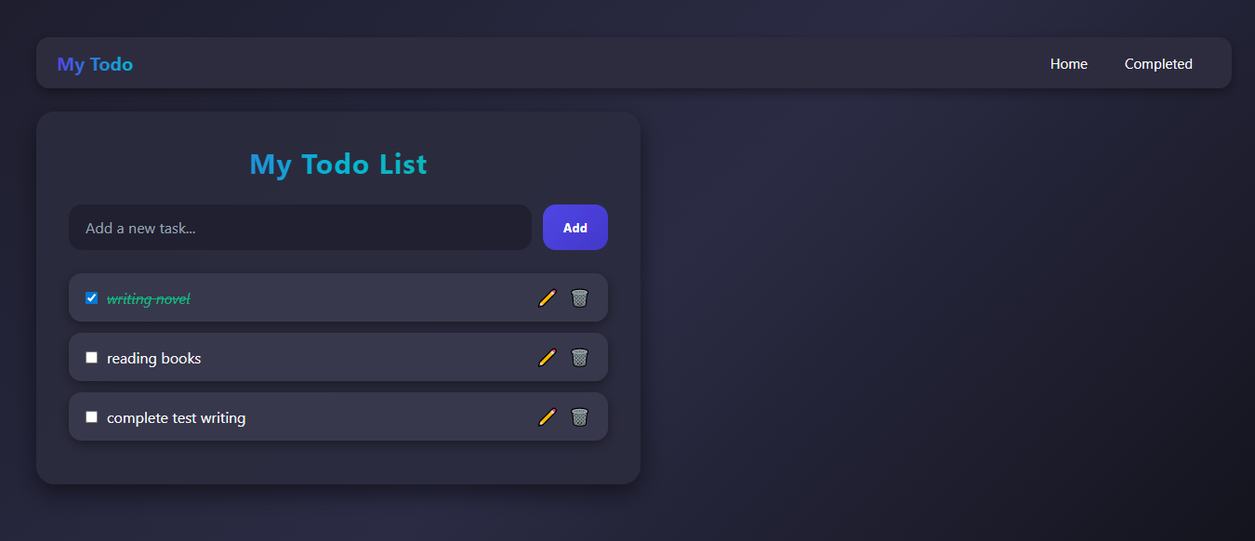
- Options to edit or delete tasks

Completed Page
- Displays completed todo tasks
- Helps users track finished work
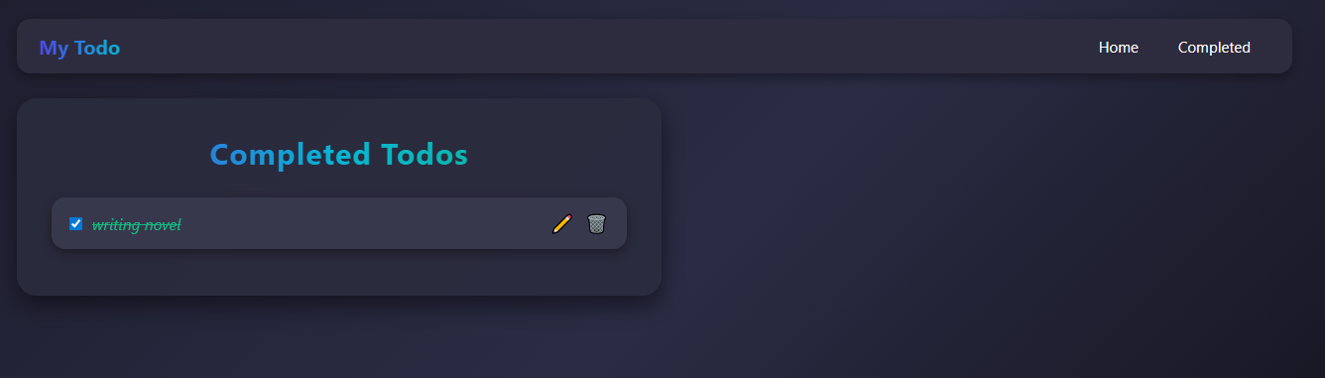

9. Security & Validation
- Input validation on frontend
- Error handling in backend APIs
- Secure MongoDB connection using environment variables

